**Systems Software**

**Continuous Assessment**

**Assignment 1**

**DT282/4**



**Student Number:** C14706715

**Name:** Jake Young

**Due Date:** 16/03/2018 @ 5pm

# Project Requirements:

1. Create a daemon to continually manage the operation of the requirements listed by the CTO above.
2. Identify new or modified site content and log details of who made the changes, this should be generated as a text file report and stored  on the server.
3. Maintain a list of site updates (file)
4. Update the live site every night (After the backup completes).
5. When the backup/transfer begins no user should be able to modify and site content.
6. It must be possible to ask the daemon to backup and transfer at any time.
7. A message queue should be setup to allow all processes to report in on completion of a task. (success or failure)
8. Error logging and reporting should be included (log to file)
9. Create a makefile to manage the creation of the executables.

### Create a daemon to continually manage the operation of the requirements listed by the CTO above.

### Identify new or modified site content and log details of who made the changes, this should be generated as a text file report and stored  on the server.

### Maintain a list of site updates (file)

### Update the live site every night (After the backup completes).

### It must be possible to ask the daemon to backup and transfer at any time.

To start I created the first daemon which I named the BackupFileDaemon. This daemon is in charge of the whole execution of the backup process. Firstly, upon execution the program will ask the user if they prefer to change the backup time from the origin time which is set to be at 23:59 every night. Once the time has been altered or not altered, the program will call the TrackChanges program to execute. The track changes program, is in charge of the website updates, it will create a file called ModificationHistory and insert into that file details regarding when the file was last modified and by which user.

After the track changes program is executed the backup of the files will be put in place. The contents from the offline folder will be copied into the live folder for the server.

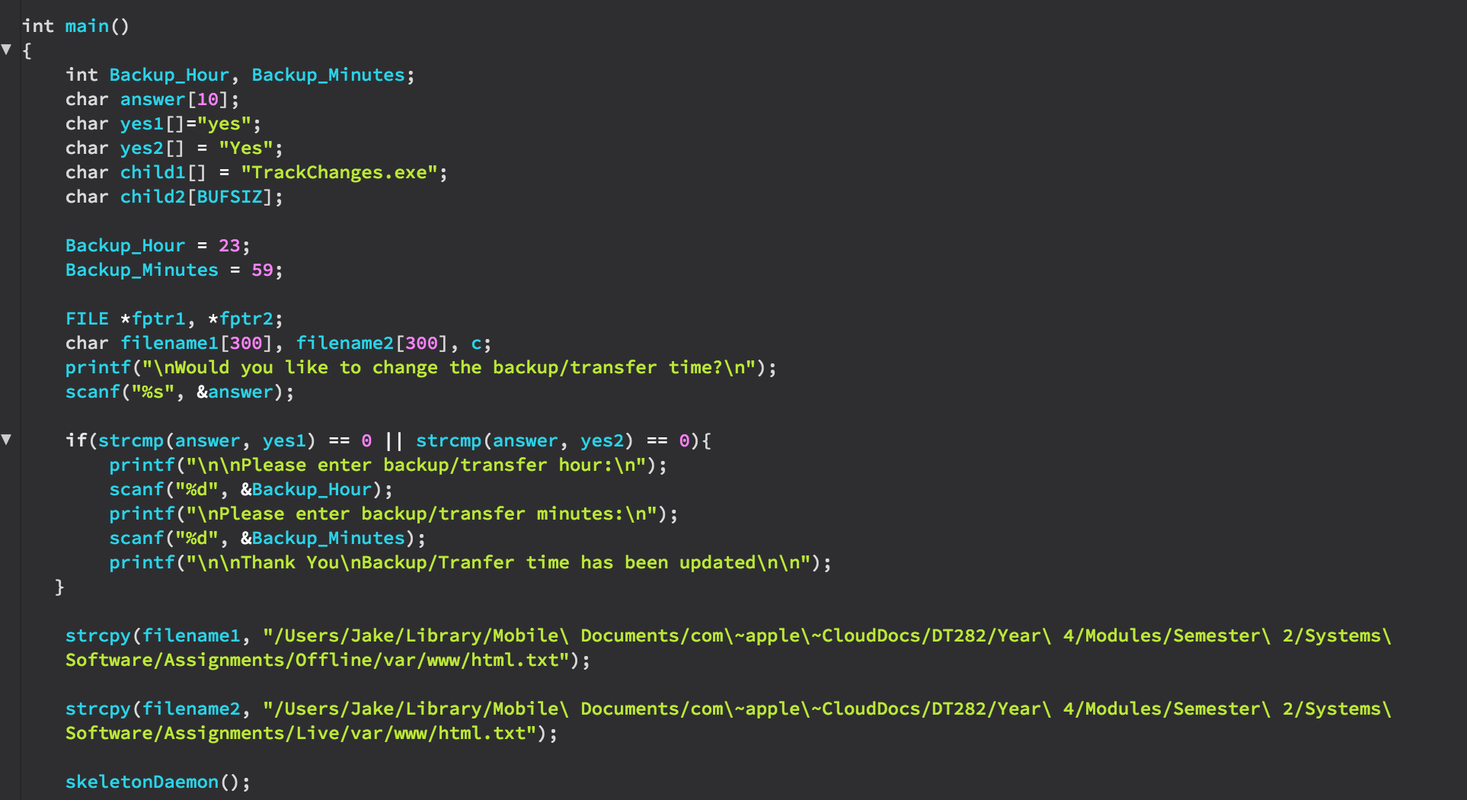

In the above screenshot you can see that in order to execute the TrackChanges program we must first pass it as a child process.

Also, you can see where the offline and live folders are in the directory.

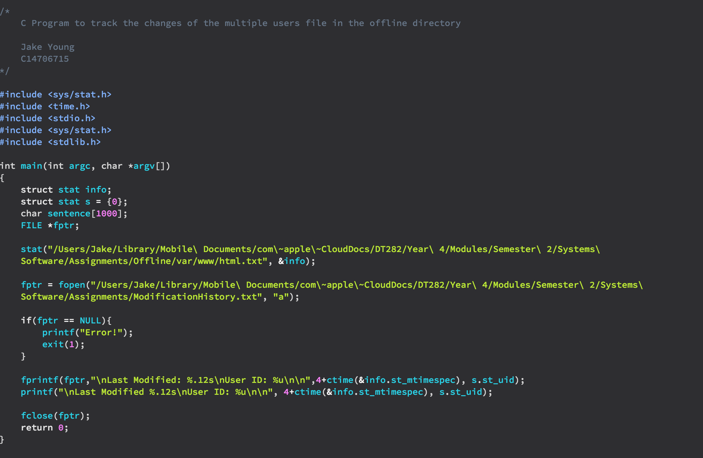

In the above screenshot you can see the code for TrackChanges. This code displays the layout for the ModificationHistory text file.

Below is a screenshot of the ModificationHistory text file.

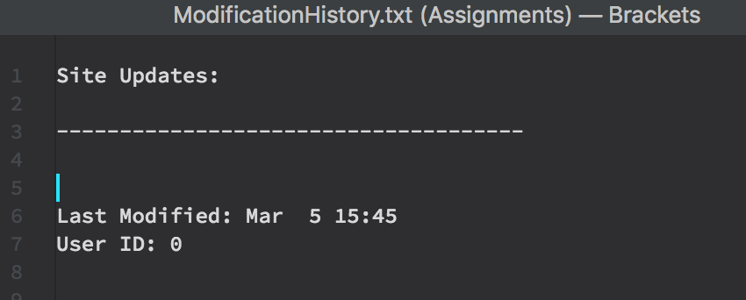

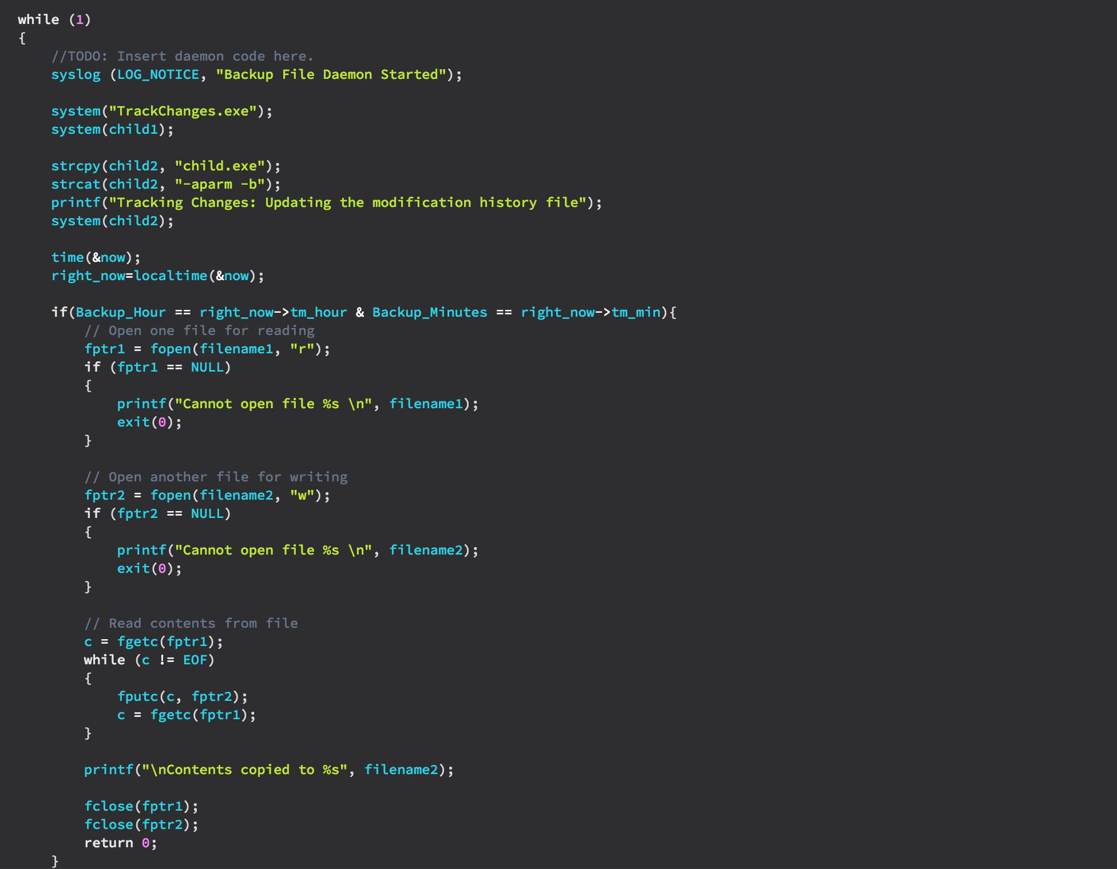

Lastly, in the above screenshot you can see the final stage of the BackupFileDaemon program where the content of the offline folder is copied into the live folder.

### When the backup/transfer begins no user should be able to modify and site content

After creating the main BackupFileDaemon, I then moved on to creating the BlockWriteDaemon the purpose of this daemon is to prevent users from writing to the offline file whilst the file is being backed up. I allocated twenty minutes to ensure ample time for backup.

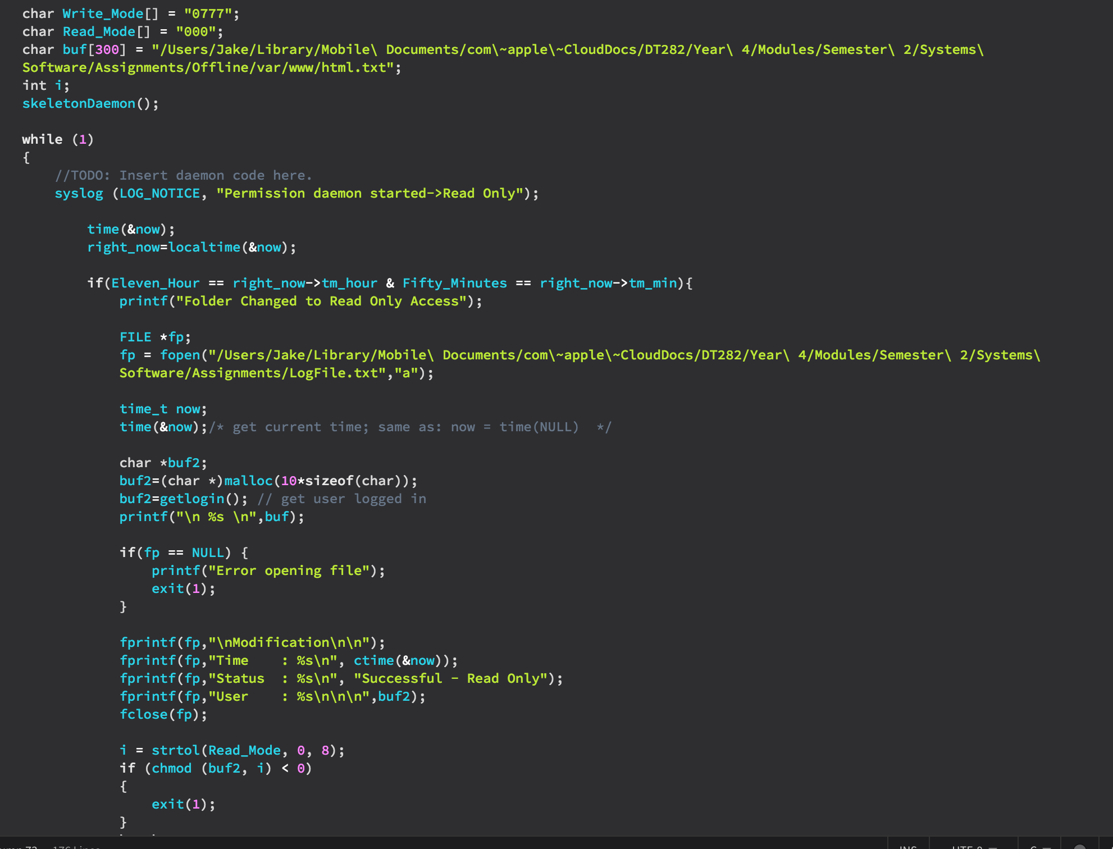

In the screenshot above you can see that I changed the access permissions for the offline file to read only as seen on next page. Also you can see the creation of the LogFile which is used to report the progress of each backup i.e. the Time, Status, and User.

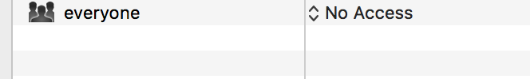

### A message queue should be setup to allow all processes to report in on completion of a task. (success or failure)

I setup a program called MessageQueue which is used to use the terminal in order to log the success of failure information.

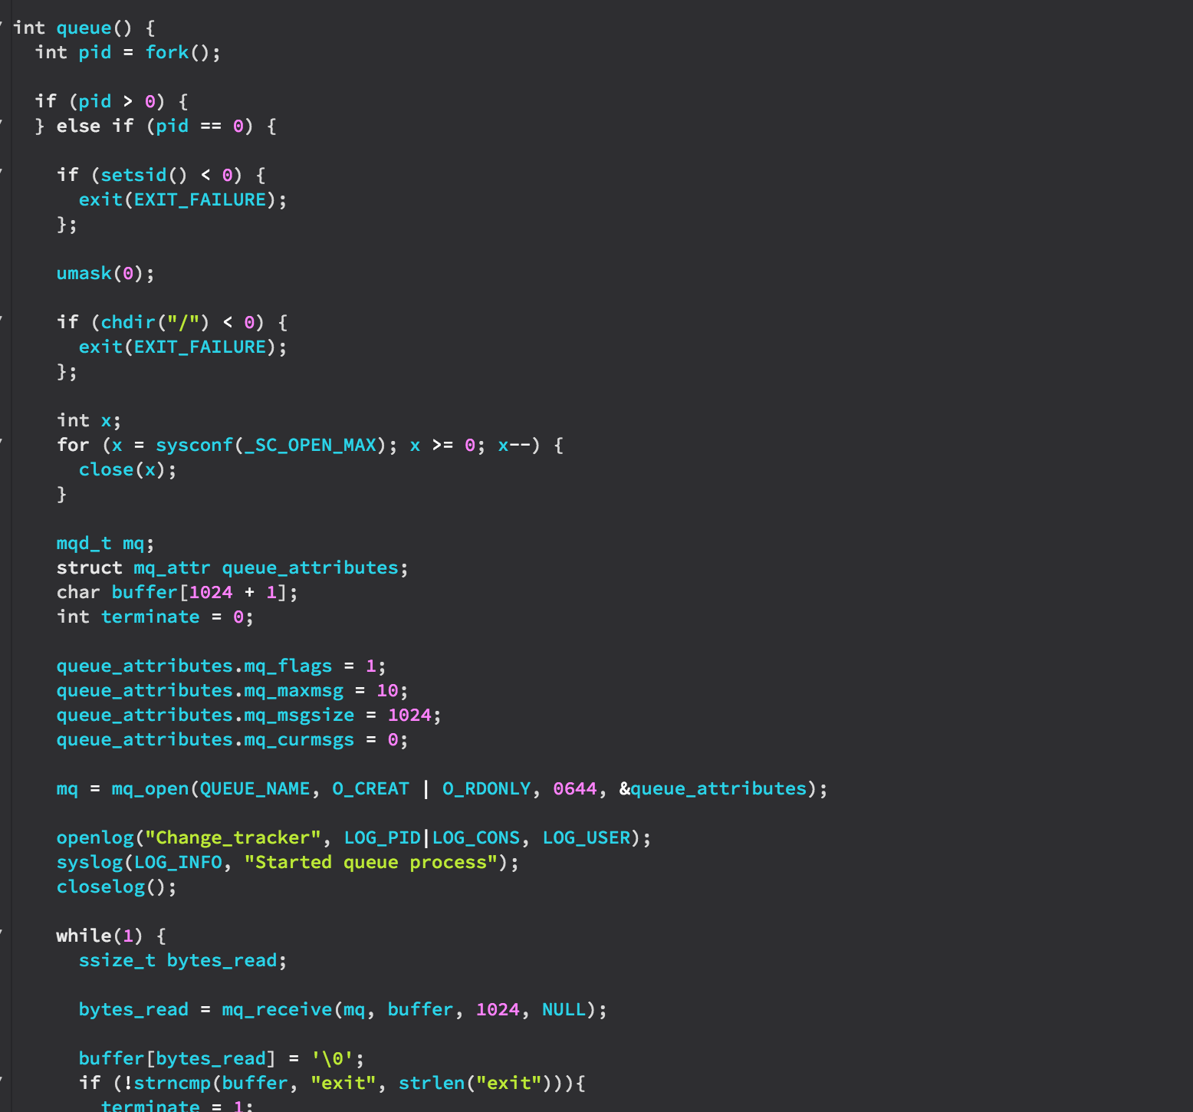

### Error logging and reporting should be included (log to file)

Error logging and reporting has been included in all of the .c files in order to reduce risks of failure and bugging as can be seen below.

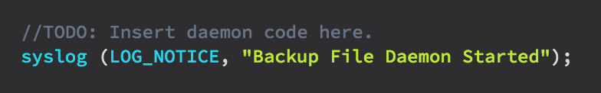



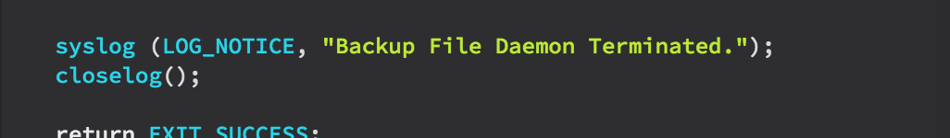

### Create a makefile to manage the creation of the executables.

The final part of this assignment was to create a makefile. In this file I have included the command to describe the objects such as BackupFileDaemon.o BlockWriteDaemon.o MessageQueue.o TrackChanges.o

I have also added in the clean command which will remove the unnecessary files from the program before compilation.

